Book

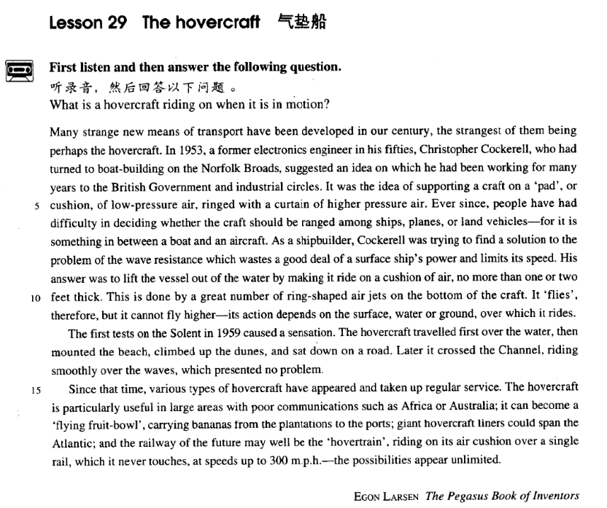

课文

Many strange new means of transport have been developed in our century,

本世纪已研制出许多新奇的交通工具，

the strangest of them being perhaps the hovercraft.

其中最新奇的要数气垫船了。

In 1953, a former electronics engineer in his fifties, Christopher Cockerell, who had turned to boat-building on the Norfolk Broads,

1953年，有一位50多岁名叫克里斯托弗.科克雷的原电子工程师，改行在诺福克郡的湖泊地区从事造船业，

suggested an idea on which he had been working for many years to the British Government and industrial circles.

他向英国政府和工业界提出了他研究多年的一项计划。

It was the idea of supporting a craft on a 'pad', or cushion, of low-pressure air, ringed with a curtain of higher pressure air.

他的设想是：用一个低压空气或软垫来支撑船体，软垫周围用高压空气环绕。

Ever since, people have had difficulty in deciding whether the craft should be ranged among ships, planes, or land vehicles -- for it is something in between a boat and an aircraft.

自那以后，人们很难决定是否应该将这种运载工具列为轮船、飞机，或是陆上交通工具，因为它是介于船和飞机之间。

As a shipbuilder, Cockerell was trying to find a solution to the problem of the wave resistance which wastes a good deal of a surface ship's power and limits its speed.

作为一个船舶技师，科克雷尔在寻找解决波浪阻力的方法，因为波浪阻力浪费掉了船在水面行驶的大量动力，从而限制了船的速度。

His answer was to lift the vessel out of the water by making it ride on a cushion of air, no more than one or two feet thick.

他的解决办法是把船体提离水面，让船在一个气垫上行驶，气垫只有一两英尺厚。船底装上大量环状喷气嘴以实现这一目的。

This is done by a great number of ring-shaped air jets on the bottom of the craft. It 'flies', therefore, but it cannot fly higher -- its action depends on the surface, water or ground, over which it rides. The first tests on the Solent in 1959 caused a sensation. The hovercraft travelled first over the water, then mounted the beach, climbed up the dunes, and sat down on a road.

这样，船就能飞了，但飞不高。它的飞行限决于它所悬浮的水面或地面。1959年，在苏伦特海峡进行的首次试航引起了轰动，气垫船先是在水面上行驶，后又登上海岸，爬上沙丘，最后停在路上。

Later it crossed the Channel, riding smoothly over the waves, which presented no problem. Since that time, various types of hovercraft have appeared and taken up regular service.

后来气垫船跨越英吉利海峡，平衡地在波浪上方行驶，波浪不再产生阻力。从那以后，各种各样的气垫船出现了，并开始了定期航行服务。

The hovercraft is particularly useful in large areas with poor communications such as Africa or Australia;

气垫船在非洲、澳大利亚等交通不发达地区特别有用。

it can become a 'flying fruit-bowl', carrying bananas from the plantations to the ports;

它能成为“飞行水果盘子”，把香蕉从种植园动到港口。

giant hovercraft liners could span the Atlantic;

大型的气垫班轮或许能跨越大西洋。

and the railway of the future may well be the 'hovertrain',

未来的火车或许能成为“气垫火车”，

riding on its air cushion over a single rail, which it never touches, at speeds, up to 300 m. p. h. -- the possibilities appear unlimited.

靠气垫在单轨上行驶而不接触轨道，时速可达每小时300英里。

词汇讲解

Lesson 29 The hovercraft

cushion ['kʊʃn]

n. 软垫，靠垫；垫状物；缓冲

cushion n. 1. a cloth bag filled with soft material that you put on a chair or the floor to make it more comfortable 软垫，靠垫

a velvet cushion

a cushion cover

cushion n. 2. a layer of sth. between two surfaces that keeps them apart

垫状物

A hovercraft rides on a cushion of air.

cushion n. 3. sth. that protects you against sth. unpleasant that might happen 缓冲

cushion a ainst …

His savings were a comfortable cushion against financial problems. cushion n. 4. the soft rubber edge of the table used for playing billiards or snooker（台球台内侧边缘的）弹性衬里

sensation [sen'seɪʃn]

n. 轰动；感觉

sensation n. 1. state of great surprise, excitement, interest, etc among many people 轰动

cause a sensation

News of his arrest caused a sensation.

The first tests on the Solent in 1959 caused a sensation.

sensation n. 2. a feeling that you get from one of your five senses, especially the sense of touch 感觉（尤指触觉）

One sign of a heart attack is a tingling sensation in the left arm.

This is supposed to induce pleasurable sensations in the elephant, and its effects are reinforced by the use of endearing epithets.

sensational adj. 轰动性的

a sensational discovery

The affair was the most sensational political sex scandal of the century.

sens / sent to fee sensation sensational sense n. 感觉，知觉；意义

sensitive adj. 敏感的

sensual adj. 肉体上的；性感的sentiment n. 情绪，感情sentimentality n. 多愁善感assent v. & n. 同意，赞成

consent v. & n. 同意，赞成

consensus n. 共识

dissent n. 异议，反对；v. 持异议，不同意

resent v. 怨恨，憎恨resentment n. 怨恨，憎恨presentiment n. 预感，凶兆plantation [plɑ:n'teɪʃn]

n. 种植园，农场

plantation n. a large area of land in a hot country, where crops such as tea, cotton, and sugar are grown（尤指热带国家的）种植园，农场

a banana plantation

plantation workers / owners

p ant to p ant（种植）；plant（植物） plantation n. 种植园，农场

plant n. 植物；工厂；设备；v. 种植；栽赃implant v. 灌输（思想）；在身体某部位植入 implantation n. （思想）的灌输；（医）植入 p ant et et sma n. 小植物，植物幼苗

transp ant trans across v. & n. 移植（植物） ；移植（器官）

transplantable adj.（植物或器官）可移植的

Many strange new means of transport have been developed in our century, the strangest of them being perhaps the hovercraft.

大 形 年 新 颜 国 材 用 + 中心名词

一张新的很沉的黑色的中国式的圆形的大木餐桌

a heavy big round new black Chinese wooden dining table a little white lamb

small black boxes a nice *cup* of tea

a beautiful *stretch* of field a stagnant *pool* of water great *lengths* of drill pipe

strange new *means* of transport a nice big *bar* of chocolate

transport n. [U] (US transportation) 交通，交通工具

A lot of people object to mobile phones, especially when they are used in public places like restaurants or on public transport.

Food, clothing, shelter, and transportation are daily necessities.

develop v. to design or make a new idea, product, system etc. over a period of time 研制，设计，开发

Scientists are developing new drugs to treat arthritis.

He claims that several countries have developed nuclear weapons

secretly.

The village seemed deserted, the only sign of life *being* an ugly-looking black goat on a short length of rope tied to a tree in a field nearby.

造句：苹果公司 (Apple Inc.) 研制出了很多有趣的新产品，其中最成

功的可能就是iPhone 了。

Many interesting new products have been developed by Apple Inc., the most successfu of them ein perhaps the ‘iPhone’.

In 1953, a former electronics engineer in his fifties, Christopher Cockerell, who had turned to boat-building on the Norfolk Broads, suggested an idea on which he had been working for many years to the British Government and industrial circles.

electronics n. 1. [U] the scientific study of electric current and the technology that uses it 电子学

a degree in electronics

the electronics industry an electronics engineer

electronics n. 2. [pl.] electronic equipment 电子设备

Weather can interfere with a car's electronics. in his fifties

in his early fifties in his mid-fifties

in his late fifties

turn to sth.: to devote or apply oneself to something, as to a field of study

致力于……

Unsuccessful in mathematics, the student turned to biology.

Norfolk n.诺福克郡 a county in eastern England, consisting mainly of rather flat farmland and some lakes called the Norfolk Broads (诺福克郡的布罗兹湖区), where many people spend holidays sailing in small boats or barges.

industrial industrious

circle n. a group of people who know each other and meet regularly, or who have similar interests or jobs（有共同兴趣、职业等的人形成的） 圈子，阶层，界

It was the idea of supporting a craft on a 'pad', or cushion, of low-pressure

air, ringed with a curtain of higher pressure air. craft n. 1. [pl. craft] a boat or ship 船舶

We passed several other craft on the river.

craft n. 2. [pl. craft] an aircraft or spacecraft 航天器，宇宙飞船

The astronauts piloted their craft down to the lunar surface.

pad n. a thick flat object made of cloth or rubber, used to protect or clean sth., or to make sth. more comfortable 垫

pad of …

Press on the wound with a large pad of cotton wool. ring v. to surround sth. 包围，环绕

Armed police ringed the hijacked plane.

be ringed with sth.

Her eyes were ringed with black lashes.

curtain n. a thing that covers, hides or protects sth. 掩蔽物，覆盖物，防护物

curtain of …

a curtain of fog / smoke

They could see nothing through the curtain of rain.

Ever since, people have had difficulty in deciding whether the craft shou d e ran ed amon ships, p anes, or and vehic es―*for it is*

*something in between a boat and an aircraft*.

ever since adv. & prep. & conj. continually since that time 从那以后，一直……

The big clock which used to strike the hours day and night was damaged many years ago and has been silent ever since.

Assuming that his family had been killed during an air-raid, Hans settled down in a Village fifty miles away where he had remained ever since.

There are countless people who, ever since their early years, have learned

to associate snails with food.

He has been depressed ever since he got divorced. have difficulty (in) doing sth.

have trouble (in) doing sth. have a hard time doing sth.

We had no difficulty (in) *finding* the house.

I had some trouble (in) *reading* his letter. His handwriting is very bad. She had a hard time *writing* the dear John letter.

range v. (fml.) to assign to a category, classify 归类，分类

in between adv. & prep. = between

I lost my keys somewhere in between the car and the house.

One town ends where the next begins and there's a road that runs in between.

As a shipbuilder, Cockerell was trying to find a solution to the problem of

the wave resistance which wastes a good deal of a surface ship's power

and limits its speed.

His answer was *to lift the vessel out of the water by making it ride on a*

*cushion of air, no more than one or two feet thick*. no more than 仅仅，只不过

We were standing no more than 10 meters away from the scene of the

crime and we didn't realize it.

When one seriously studies the social orders that have had the

opportunity to develop autonomously, the figure becomes no more than an exact and matter-of-fact observation.

not more than 最多……，不超过……

She is not more than thirty.

no less than+数词+计量名词(时间；距离；金额)

足足有……；有……之多

not less than+数词+计量名词(时间；距离；金额)

至少有……；不少于……

no fewer than+ 数 词 + 普 通 名 词

足足有……；有……之多

not fewer than+数词+普通名词 至

少有……；不少于…… nothin ut … 只，只有

He had nothing but a cup of tea this morning．

William S. hart was, perhaps, the greatest of all Western stars, for unlike Gary Cooper and John Wayne he appeared in nothing but Westerns.

I have heard of writers who read nothin ut their own ooks; … nothing more than（贬义）只不过是

He dismissed Bryan as nothing more than an amateur.

This is done by a great number of ring-shaped air jets on the bottom of

the craft.

-shaped suffix used with many nouns to make adjectives describing the shape of somethin ……形状的

a V-shaped collar

an L-shaped room a heart-shaped leaf

a crescent-shaped scar oddly shaped forms

several curiously shaped bits of metal a large curiously shaped bottle

jet n. a narrow stream of liquid or gas that comes quickly out of a small hole, or the hole itself 喷射；喷嘴

to clean the gas jets on the cooker

She soaped herself beneath the refreshing jets of water.

It 'flies', therefore, but it cannot f hi her―its action depends on the surface, *water or ground*, over which it rides.

The first tests *on the Solent in 1959* caused a sensation.

Solent: A narrow channel between the Isle of Wight and the southern mainland of England. The Solent provides access to the port of Southampton. 苏伦特海峡

The hovercraft travelled first over the water, then mounted the beach,

climbed up the dunes, and sat down on a road.

mount v. 1. go up, ascend 登上

He mounted the platform and addressed the crowd.

A car suddenly mounted the pavement to avoid a vehicle coming in the opposite direction.

mount v. 2. to fix sth. into position on sth., so that you can use it, look at it or study it 将某物固定住（以备使用、展示或研究）

Triple gun-decks mounted sixty-four bronze cannon.

mount v. 3. to increase gradually 逐渐增加

The death toll continues to mount.

This modern faith in medicines is proved by the fact that the annual drug bill of the Health Services is mounting to astronomical figures and shows no signs at present of ceasing to rise.

mount v. 4. get onto or put sb. onto a horse, etc. for riding（使）骑上马等

He quickly mounted his horse and rode away. He mounted the boy on the horse.

The policemen were mounted on black horses.

Two assistants, mounted on tame elephants, control the captive from either side, …

Later it crossed the Channel, *riding smoothly over the waves, which*

*presented no problem*.

be / pose / present a pro em for …

Racial tensions in the south of the city pose a real problem for the police. The high rate of inflation presents a serious problem for the government. be / pose / present / constitute a hazard to …

be / pose / present / constitute a threat / menace to …

*Since that time*, various types of hovercraft have appeared and taken up regular service.

take up v. start or begin sth, esp. a job 开始（某种工作等）

She has taken up a job as a teacher.

service n. [U] used to talk about whether a piece of equipment, a vehicle etc. is available to be used, or how long it can be used （设备，交通工具等）被使用，得到使用

These trains have been in service for many years.

The escalator is still out of service.

Steel tools can give good service for years.

The hovercraft is particularly useful in large areas with poor communications such as Africa or Australia; it can become a 'flying fruit-bowl', carrying bananas from the plantations to the ports; giant hovercraft liners could span the Atlantic; and the railway of the future may well be the 'hovertrain', riding on its air cushion over a single rail, which it never touches, at speeds up to 300 m.p.h. ―the possi i ities appear unlimited.

communications n. [pl.] roads, railways etc that are used for travelling and sending goods 交通

Paris has good communications with many European cities.

Its commercial success as a city is partly due to its excellent rail and road communications.

fruit bowl n. A fruit bowl is a large bowl in which fruit is kept and displayed. 果盘

liner n. a large ship for passengers 客轮，班轮

The tragic sinking of this great liner will always be remembered, for she went down on her first voyage with heavy loss of life.

span v. to stretch right across sth, from one side to the other 跨越，贯穿

a series of bridges spanning the river

may / might / could we … used to sa that sth. is ike to happen or is likely to be true （某事）可能（发生或是真的）

Another patient might equally well complain that her neighbours were

combining to slander her and persecute her, and yet one might be cautious about believing this statement.

Over the years one may well become an authority on one's hobby and will very probably be asked to give informal talks to little gatherings and then, if successful, to larger audiences.

Apart from moral considerations this is a stupid method of training, for it produces a resentful animal who at a later stage may well turn man-killer. possibilities n. [pl.] capability of being used or improved, potential 潜 在

价值，潜力

The house is very dilapidated but it has possibilities. He was the first to see the possibilities of the plan.

unlimited adj. as much or as many as is possible, not limited in any 无 限

的，无穷的

Demand for health care appears virtually unlimited.

This new technology opens up almost unlimited possibilities.